

EMBEDDED SYSTEM ASSIGNMENT 03

KANWAL SHEHZADI 02-131212-027



Q: 01) Design an embedded system in which LM35 is connected with analog pins of a microcontroller that measures the atmospheric temperature on an LCD screen.

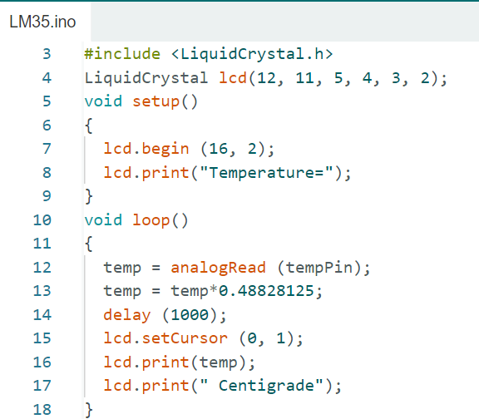

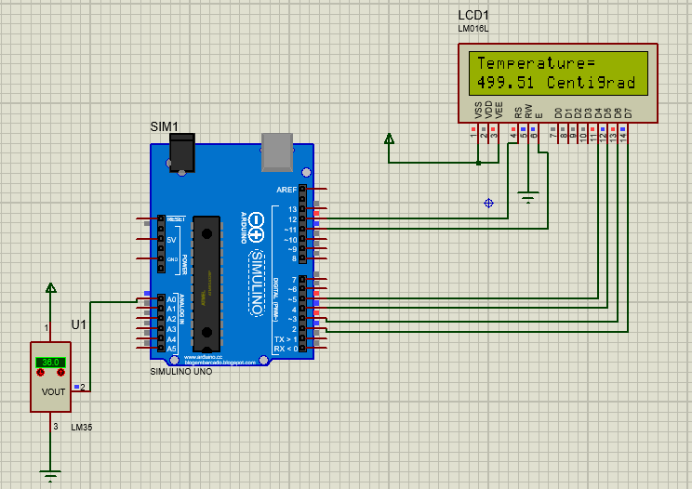

Q: 02) Design an embedded system in which variable resistor connect with analog pins of the microcontroller, which takes voltage from vcc pin of 3.75V, and measure the analog value from the microcontroller. Further LCD displayed the supply voltage, and its analog value and then mapped the analog value into voltage form. Finally, measure its error between supply and measure analog value.

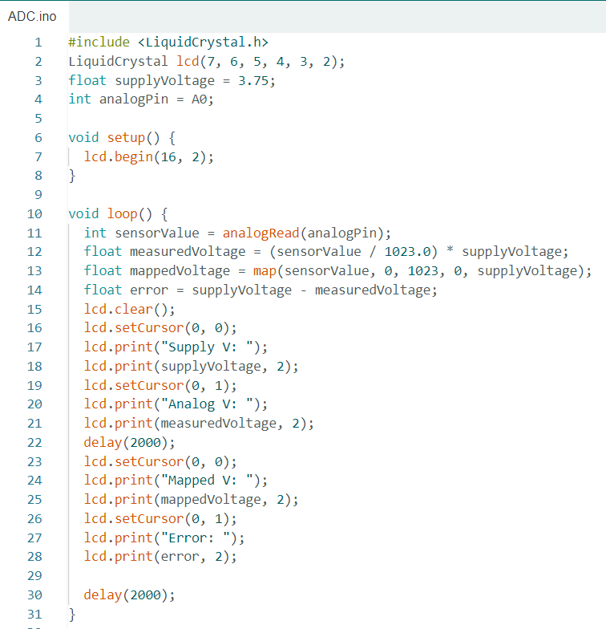

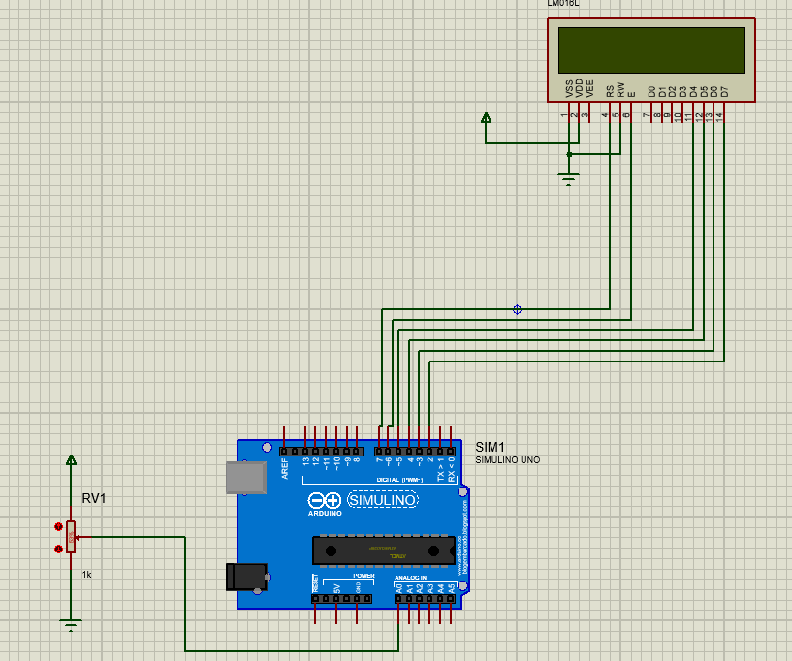

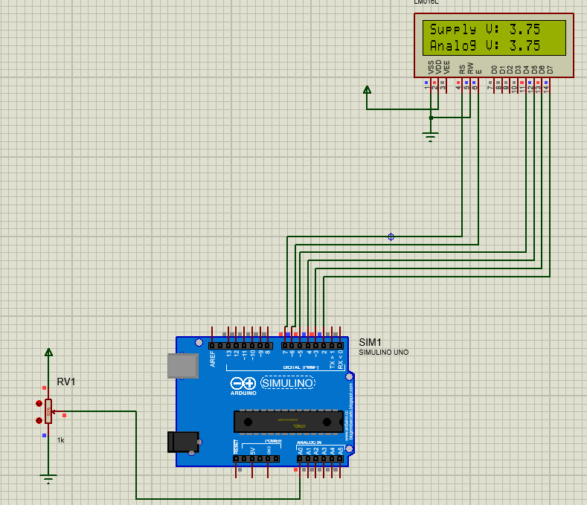

Q: 03) Design an embedded system in which LDR connected with analog pins of microcontroller that measure the intensity of the light LCD screen.

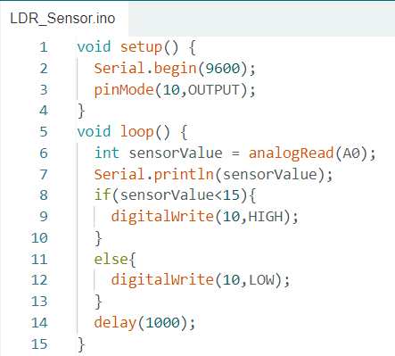

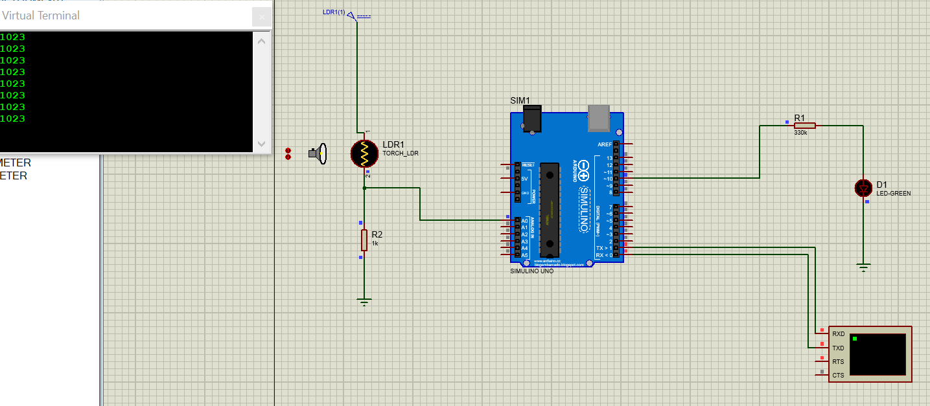

Q: 04) Design an embedded system in which ultrasonic sensor connect with analog pins of microcontroller that measure the distance of the object LCD Screen.

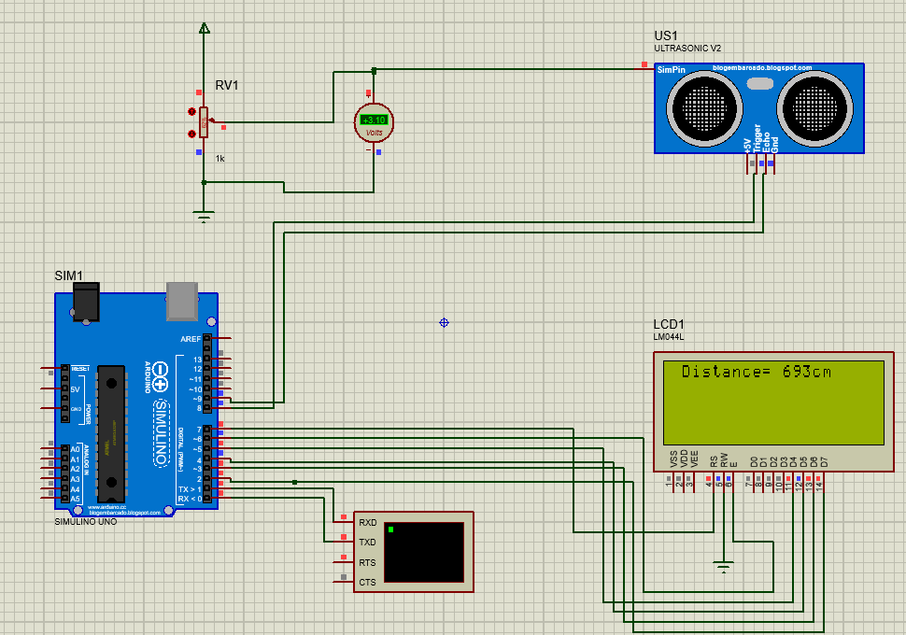

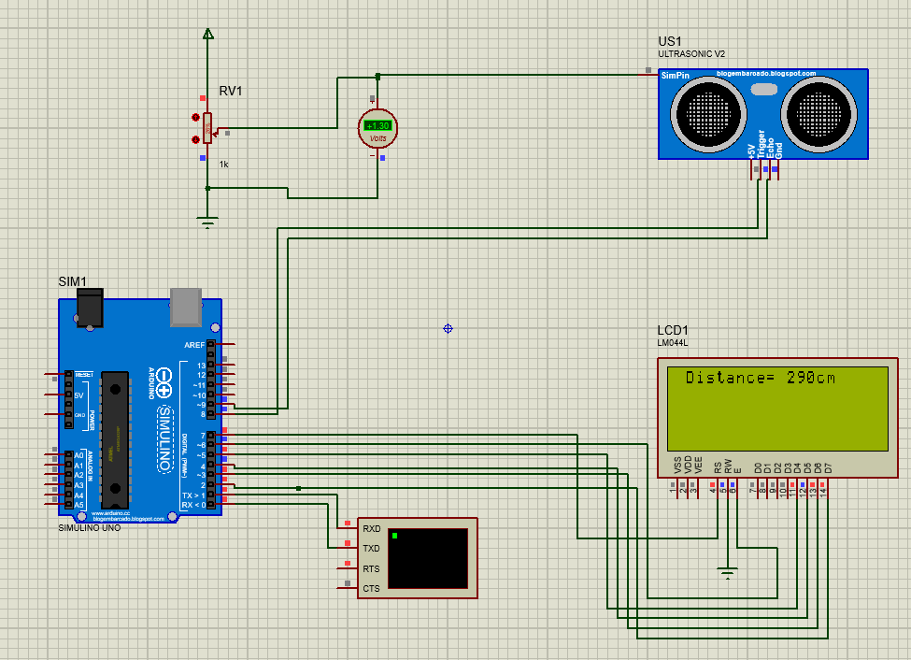

Q: 05) Design an embedded system in which PIR sensor connect with analog pins of microcontroller that measure the motion of the object and displayed on LCD.

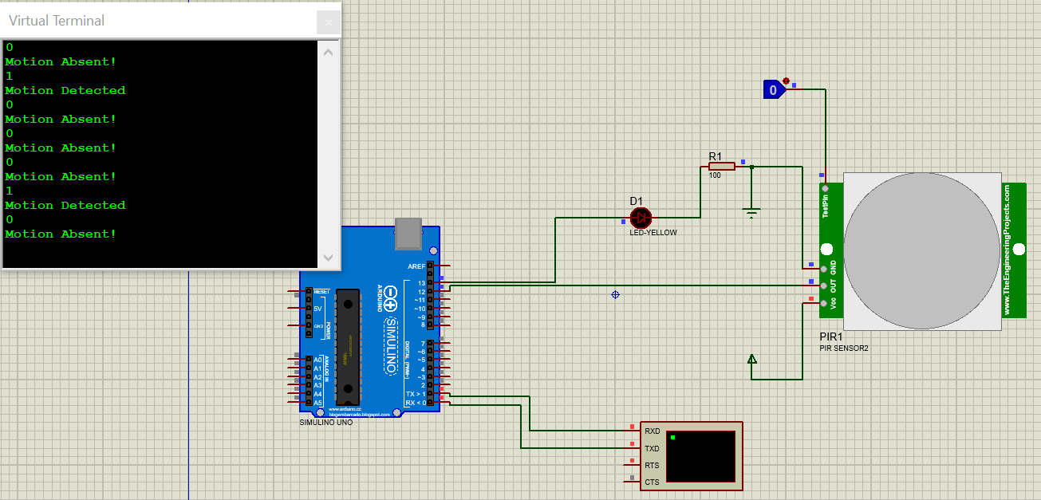

Q: 06) Design an embedded system in which soil moisture sensor connect with analog pins of microcontroller which measure the intensity of water on soil and display on LCD.

